Darshana pubudu keerthirathna

ICM 106 OR23106564

DATABASE MANAGEMENT SYSTEM – WEEK 03 ASSIGNMENT

**Question 01**

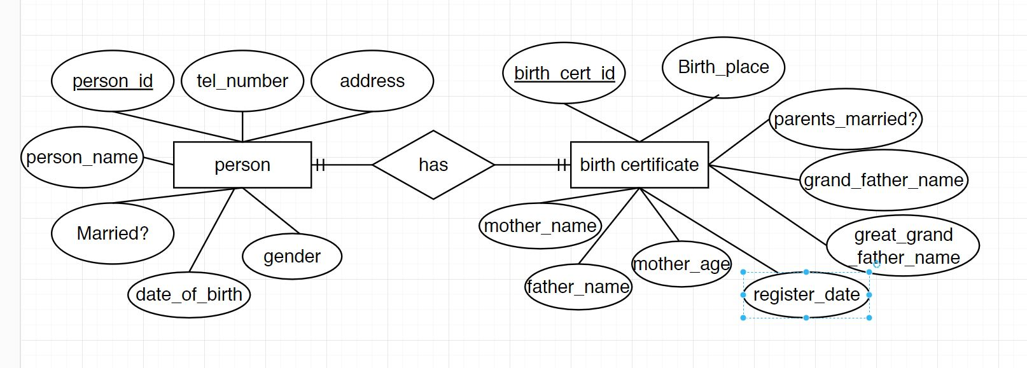

**Question 02**

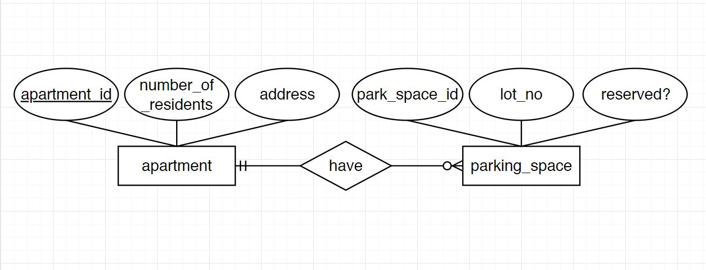

**Question 03**

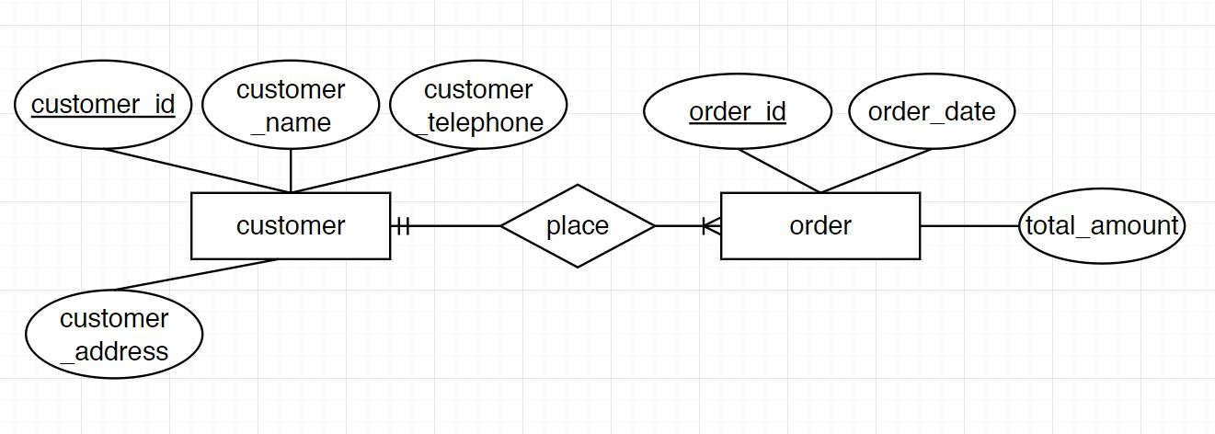

**Question 04**

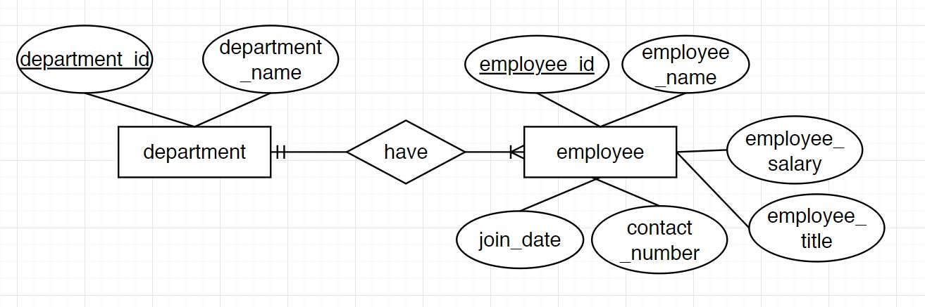

**Question 05**

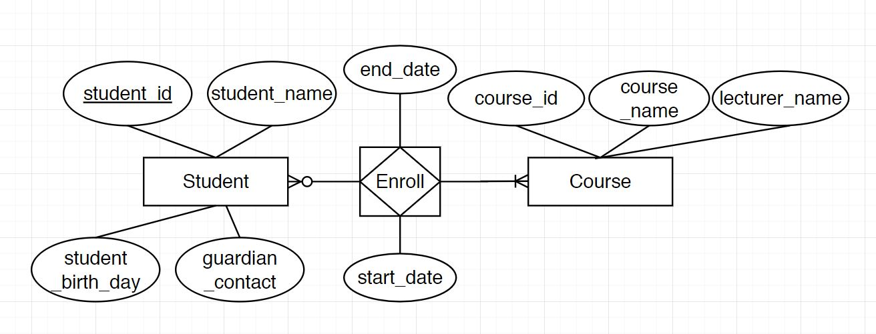

**Question 06**

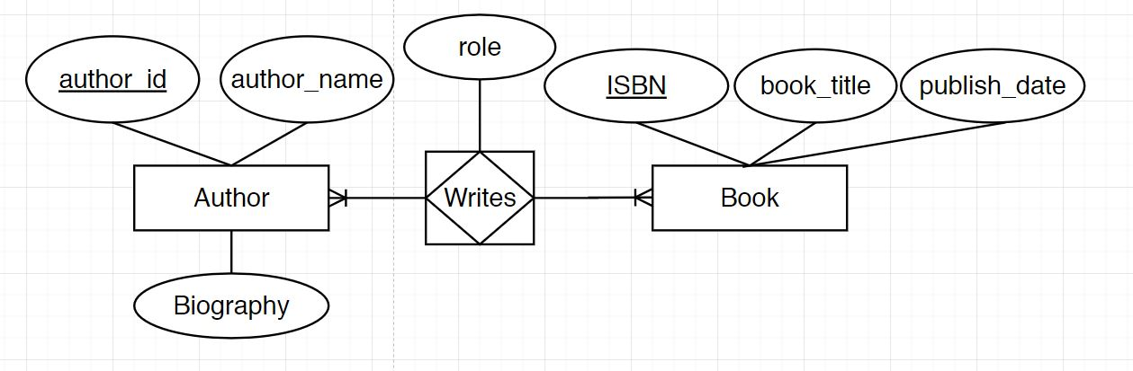

**Question 07**

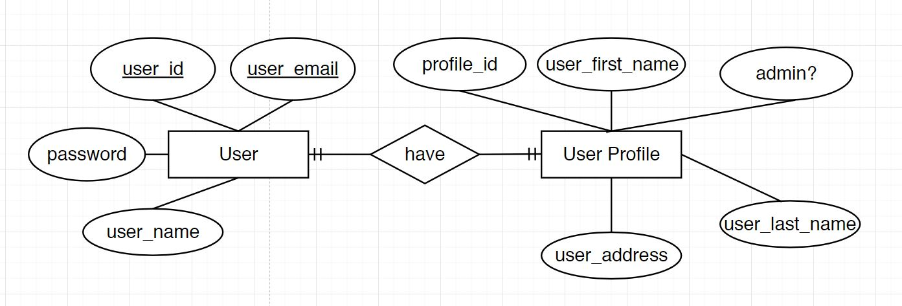

**Question 08**

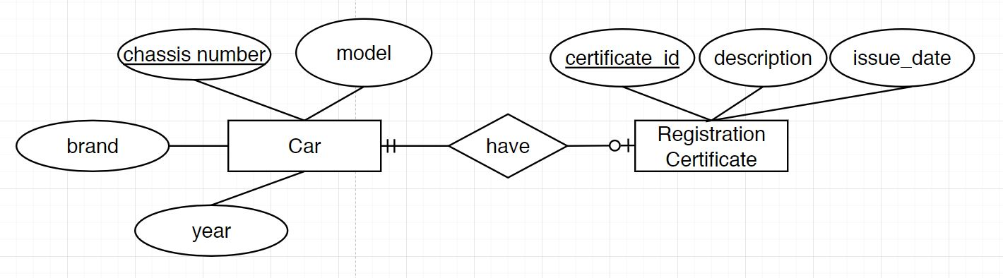

**Question 09**

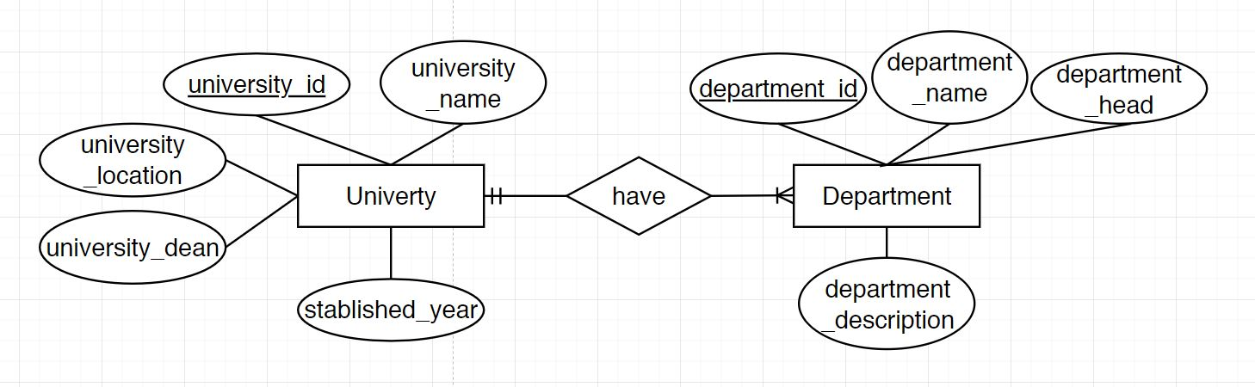

**Question 10**

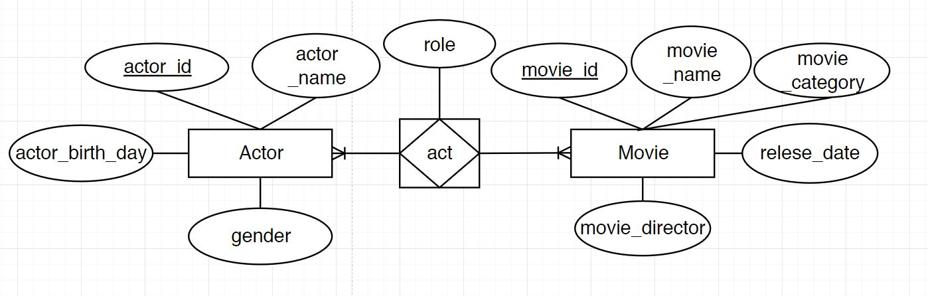

**Question 11**

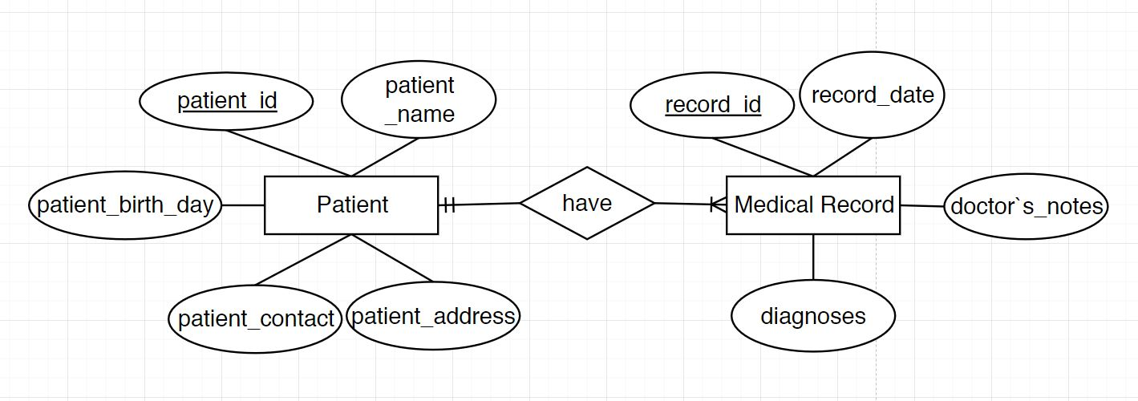

**Question 12**

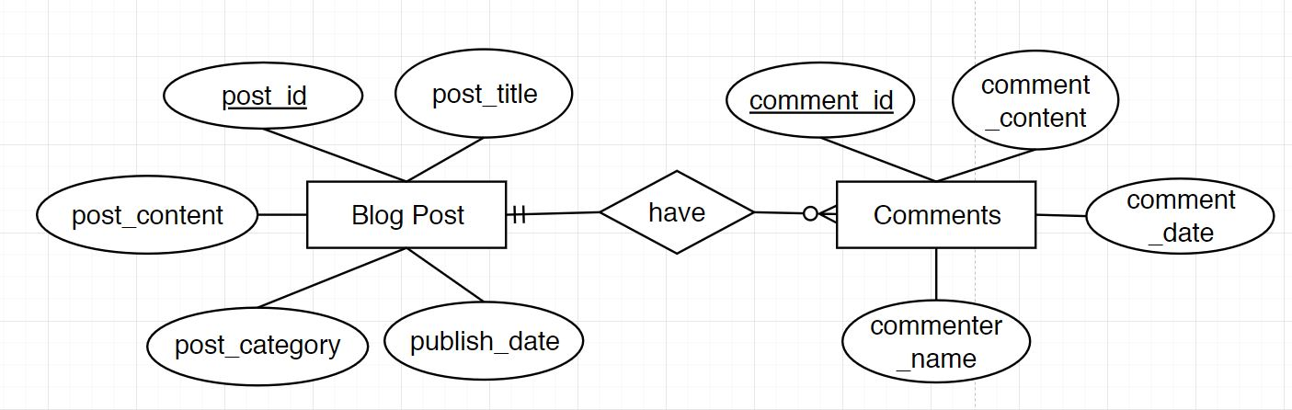

**Question 13**

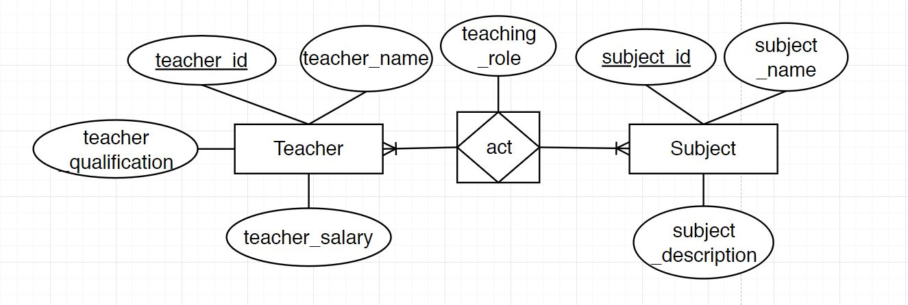

**Question 14**

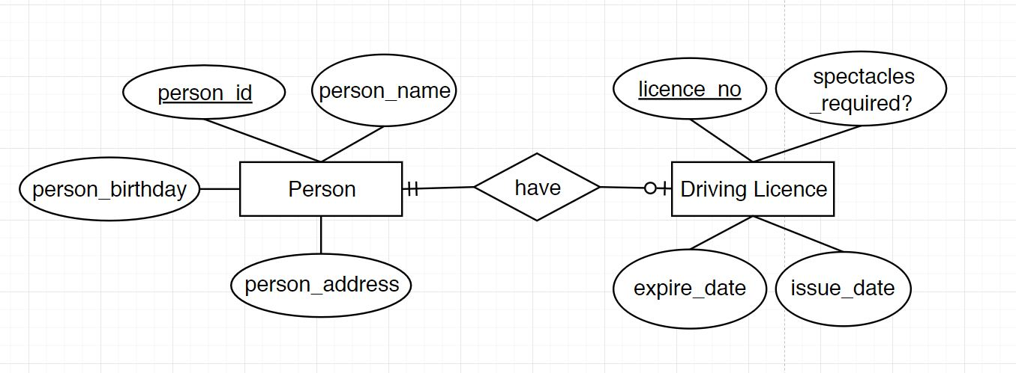

**Question 15**

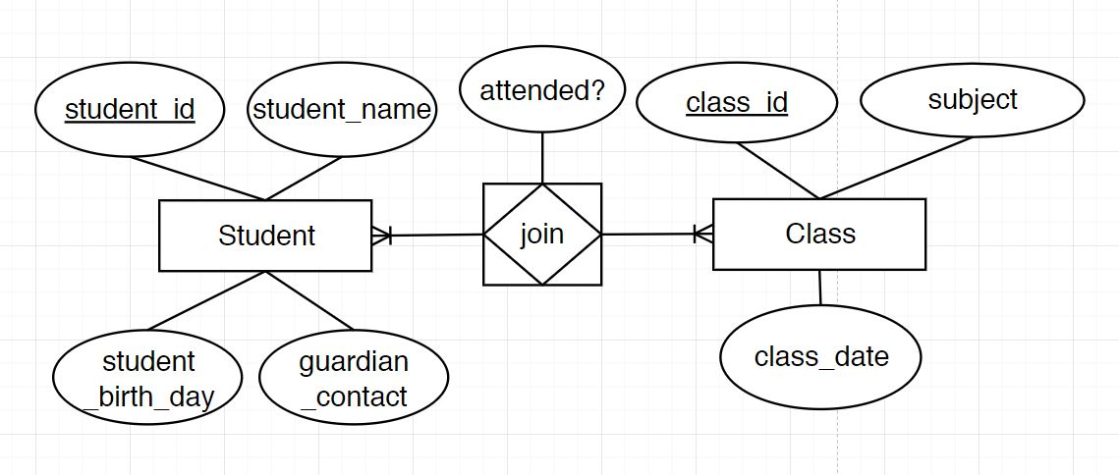

**Question 16**

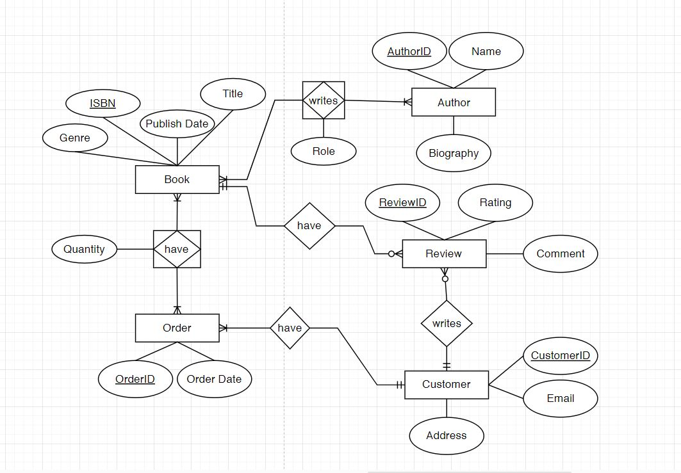

**Question 17**

